 | Massachusetts Department of Environmental Protection  Bureau of Resource Protection - Wetlands  WPA Form 8A – Request for Certificate of Compliance  Massachusetts Wetlands Protection Act M.G.L. c. 131, §40  Foxborough Wetlands Protection Bylaw, Chapter 267 (formerly Article IX) |  |  |  |  | DEP File Number:  157-  Provided by DEP
 | A. Project Information
Important: When filling out forms on the computer, use only the tab key to move your cursor - do not use the return key.  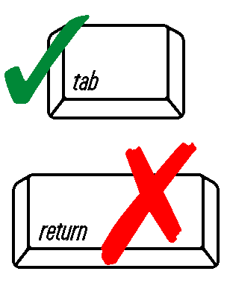 | 1. This request is being made by:
 | Name
 | Mailing Address
 | City/Town |  |  | State |  | Zip Code
 | Phone Number
 | 2. This request is in reference to work regulated by a final Order of Conditions issued to:
 | Applicant
 | Dated |  |  | 157-  DEP File Number
Upon completion of the work authorized in  an Order of Conditions, the property owner must request a Certificate of Compliance  from the issuing authority stating that the work or portion of the work has been satisfactorily completed. | 3. The project site is located at:
 | Street Address |  |  | Foxborough  Town
 | Assessors Map/Plat Number |  |  | Parcel/Lot Number
 | 4. The final Order of Conditions was recorded at the Registry of Deeds for:
 | Property Owner (if different)
 | Norfolk  County |  | Book |  |  | Page
 | Certificate (if registered land)
 | 5. This request is for certification that (check one):
 | the work regulated by the above-referenced Order of Conditions has been satisfactorily completed.
 | the following portions of the work regulated by the above-referenced Order of Conditions have been satisfactorily completed (use additional paper if necessary).
 | the above-referenced Order of Conditions has lapsed and is therefore no longer valid, and the work regulated by it was never started.
 | A. Project Information (continued)
 | 6. Did the Order of Conditions for this project, or the portion of the project subject to this request, contain an approval of any plans stamped by a registered professional engineer, architect, landscape architect, or land surveyor?
 | Yes | If yes, attach a copy of the As Built Plan and a written statement by such a professional certifying substantial compliance with the plans and describing what deviation, if any, exists from the plans approved in the Order.
 | No
 | 7. Request for Certificate of Compliance (Bylaw) Filing Fee
 | $  Filing Fee | Fee = $100.00 for single family homes.  $200.00 for other projects.
Tax Collector’s Release
The above referenced applicant is applying for a permit from the Conservation Commission and is in good standing with respect to any taxes, fees, assessments, betterments or other municipal charges as recorded with the Foxborough Treasurer’s Office.

 | Signature of Tax Collector or Agent |  |  |  | Date
 | B. Submittal Requirements
Requests for Certificates of Compliance should be directed to the issuing authority that issued the final Order of Conditions (OOC).
If the project received an OOC from the Conservation Commission, submit this request to the Commission. Application fee checks should be made payable to “Town of Foxborough.”
Foxborough Conservation Commission
Town Hall, 40 South Street, Foxborough, MA 02035

If the project was issued a Superseding Order of Conditions or was the subject of an Adjudicatory Hearing Final Decision, submit this request to the DEP Southeast Regional Office.
MassDEP
Southeast Regional Office
20 Riverside Drive
Lakeville, MA 02347

 | This form must be signed and dated by the Foxborough Treasurer’s Department, when submitted.

